Institute of Development Studies

DCI-ASIE/2014/350-601
EU-China Social Protection Reform Project
Component 1: Support to strengthen NDRC institutional capacity
for the development and implementation of Social Protection reforms

First Six-months Component Status Report
17 November 2014 – 16 May 2015

Report submitted by the
Agency for the Development and Coordination
of International Relations
(ADECRI) - France,
Component 1 Coordinator

(second draft)

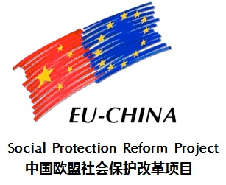

May 2015

TA to improve and develop the Social

Introduction
This first Component 1 Status report presents component-related activities under the first six-months of the project, i.e. the first six months elapsed since its signature on 17 November 2014. This period initiated after the identification of the EU Resident expert for Component 1, Mr Jean-Victor Gruat who officially started working for the project on 20 December 2014. A high level international workshop was held in Brussels on 2 and 3 February 2015, under Component 1 auspices - Macro-activity 1.5. Further, a technical exploratory visit to Beijing - 9 to 16 February 2015 - common to all three resident experts with component-related specificities allowed for discussions to be held directly with NDRC on programmatic issues, including activities to be considered and conducted during the first six months, the first calendar year and the whole duration of the project. The EU resident experts returned to Beijing in early March 2015 to start implementing project activities. A visit by the project leader, Mr Gabriele Uselli, took place between 16 and 20 March 2015 notably to help prepare the meeting of the Project advisory committee – PAC - held on 21 April 2015. The PAC meeting endorsed the Plan of activities prepared for each of the project components and horizontal themes. It also decided to hold a six-months frequency for the production of component reports, instead of the quarterly pace foreseen in the Grant application form.
During the period under review, the project component established in close cooperation with NDRC counterparts and the EU Delegation methods of work to ensure the efficiency and the sustainability of its interventions. The component therefore could make substantial progress in implementing activities related to the analysis phase foreseen in the Grant application form – macro-activities 1.1. Chinese experts were identified and recruited for undertaking national analysis of the three topics selected as priorities for the first half of the year 2015. Preparatory work for holding in France of a two weeks training course on Multi-tier pension systems were also completed thanks to a fruitful cooperation between ADECRI, the Component coordinator, and NDRC, the beneficiary of the training session. The preliminary reports announced in the Grant application form as part of the preparatory works for project implementation – macro-activity 0.1, point 3. – were completed in due time.
The core team in charge of implementing project activities related to component 1 was established and is fully operational. It is composed of the C1 EU Resident expert, 2 part time Main Chinese experts – Research, and Operation – and a part-time Component assistant. Planning of activities and of required matching human resources (Chinese as well as European) was duly established, shared with and endorsed by NDRC and the Component coordinator. However, the lasting uncertainties and inefficiencies in administrative procedures undoubtedly affected the quality of the work conducted under the component’s auspices. These difficulties are not overcome at the time of writing this report, which is a matter of serious preoccupation for the component coordinator.
This report supplements the monitoring tables produced as requested by the project leadership in a separate document.

Laurent de Lespinay,
Coordinator Component 1,
16 May 2015.

NB. While ADECRI was still ensuring the coordination of project C1 activities during the period covered by this report, that function was subsequently entrusted to Expertise France, which absorbed ADECRI and its functions as of 15 June 2015.

Contents
Introduction 1
List of Tables 4
Table of Annexes 5
Relevant Acronyms 6
1 Objectives of the Component, policy and programme context 8
1.1 Results pursued 8
1.2 Topics to be considered 9
1.3 Best practices 10
1.4 Beneficiaries 10
1.5 Planning for overseas activities 11
2 Activities 13
2.1 Horizontal Activities- Macro-activity 0.1 – Inception 14
2.1.1 Human resources 14
2.1.2 Finalization of the detailed activity plan 16
2.2 The Brussels International Workshop 17
2.3 Other component-specific activities 18
2.3.1 Assessment reports and best practices 19
2.3.2 Training and study visits abroad 19
3 Planning for next period (17 May – 16 November 2015) 21
3.1 Research reports 22
3.2 Overseas activities 23
3.2.1 Training on multitier systems 23
3.2.2 Study visit on Migrant workers 24
3.2.3 Planning for 2016 24
3.3 Pilot sites 25
4 ANNEXES 27

List of Tables

Table 1 - Expected results, Component 1 8
Table 3 – Topics to be considered in 2015, component 1 10
Table 4 - Procedures and Criteria, Overseas Activities 11
Table 5 – C1, EU MS Public sector staff, 2015 - Planned 14
Table 6 – Planned use of Chinese experts w/d – C1, 2015 15
Table 7 – C1, Contractual commitments 17 Nov.2014-16 May 2015, w/d and % 16
Table 8 – C1, Selected pilot sites 17
Table 9 – C1, Progressive introduction of topics 21

Table of Annexes
Annex 1
Interrelation Results, Problems, Cross-Cutting Issue 28
Annex 2
Topics and sub-topics - Examples of European best practices 31
Annex 3
C1 specific Logical framework (revised) 40
Annex 4
Programme of the Brussels Workshop 44
Annex 5
C1 GANTT Activity plan – March 2015 to February 2016 48
Annex 6
C1 Main activities and outputs - April 2015 to January 2016 55
Annex 7
Training on Multitier pension systems 61

Relevant Acronyms

Acronym | Description
ACFTU | All-China Federation of Trade Unions
ACWF | All-China Women's Federation
ADECRI | Agence pour le Développement et la Coordination des Relations Internationals (Agency for the Development and Coordination of International Relations)
CEC | China Entreprise Confederation
CASS | China Academy of Social Science
CIRC | Chinese Insurance Regulatory Commission
CMBII | Programme for Strengthening the Basic Health Care Coverage
CPC | Communist Party of China
DPRC | Disabled People Rehabilitation Centres
EN3S | Ecole Nationale Supérieure de Sécurité Sociale (National School of Advanced Social Security Studies)
ENPI | European Neighbourhood & Partnership Instrument
ESF | European Social Fund
EU | European Union
EU MS | European Member State
EUD | European Union Delegation
HRD OP | Human Resources Development Operational Programme
IAC | Insurance Association of China
IASIA | International Association of Schools and Administration Institutes
IBRD | International Bank of Reconstruction and Development
ICT | Information and Communication Technology
ILO | International Labour Organization
IMC | Internal Management Committee
IPA | Instrument for the Pre-Accession Assistance
IPSAS | International Public Sector Accounting Standards
ISSA | International Social Security Association
LAC | Latin America & the Caribbean
M&E | Monitoring and Evaluation
MIDAS | Micro-simulation for the Development of Adequacy and Sustainability
MII | Minimum Insertion Income
MIS | Management Information System
MoA | Ministry of Agriculture
MoCA | Ministry of Civil Affairs
MoF | Ministry of Finance
MOFCOM | Ministry of Commerce
NHFPC | National Health and Family Planning Commission;
MoHRSS | Ministry of Human Resources and Social Security
NDC | Notional Defined Contribution
NDRC | National Development and Reform Commission
NGO | Non-Governmental Organization
NOP | National Operating Programmes
NRP | National Reform Programmes
NSR | National Strategy Reports
OECD | Organization for Economic Co-operation and Development
OHS | Occupational Health & Safety
OMC | Open Method of Coordination
OPHRD | Operational Programme Human Resources Development
PAC | Project Advisory Committee
SAFEA | State Administration of Foreign Experts Affairs
SAI | Shanghai Administration Institute
SAWS | State Administration for Work Safety
SOCIEUX | Social Protection European Union Expertise in development cooperation
ToR | Terms of Reference
UNDP | United Nations Development Programme
WB | World Bank

Objectives of the Component, policy and programme context
CHAPTER

CHAPTER

This report describes delivery of activities under the Component 1 - Support to strengthen NDRC institutional capacity for the development and implementation of Social Protection reforms - of the EU-China Social Protection Reform Project. It covers the period 17 November 2014 to 16 May 2015.
The Grant was signed on 17 November 2014. The EU Resident expert for Component 1, Mr Jean-Victor Gruat (ADECRI) had been selected following an interview conducted on 29 October 2014. The contract of the Resident expert took effect on 20 December 2014.

Results pursued
Component 1 of the project has specifically to pursue 4 of its altogether 11 identified results - results R2 to R5 inclusive -, namely:
- Improved interagency cooperation in social protection reform;
- Enhanced capacity in policy development, implementation and evaluation;
- Strengthening the interface of the various pension schemes towards full coverage in old-age; and,
- Reform efforts in response to urbanization trends, concerning notably basic protection and portability of rights.
NDRC is the main stakeholder and beneficiary for Component 1 activities.
Table 1 - Expected results, Component 1
R2 | Under the leadership of the NDRC, coordination of policy making among government agencies in areas related to social protection reform is strengthened.
R3 | The capacity of the NDRC in policy development and implementation, notably establishing and enforcing a national policy evaluation technique in the area of social protection, is enhanced.
R4 | National policy framework for a full coverage of old-age insurance system throughout China is consolidated by strengthening the interface of various schemes, pension funding pooling, old-age insurance scheme for civil servants/the employee of public agencies and the existing multi-layer pension system.
R5 | Reform efforts in response to urbanization trends, in particular the harmonization and integration of the various basic social protection systems for different groups of beneficiaries, the portability of social insurances and better suited assistance schemes.

Annex I shows the inter-relations between results to be achieved under Component 1, Problems & Needs identified during project formulation and crosscutting issues.

Topics to be considered
For each of the project expected results, specific topics were identified during the phase of elaboration of the Grant Application Form. A total of 16 topics were considered as particularly relevant under the results assigned to Component 1 of the project, as shown in Table 2 below.
Table 2 - Topics to be considered, Component 1
Result | Topic
R2 | Social insurance administration systems reform – Contribution to the XIIIth Five-Years Plan
R2 | Coordination of policy making among government agencies in areas related to social protection reform
R3 | Relationship of pension benefit with minimum social wage
R3 | National policy evaluation technique in the area of social protection (indicators, methods and programs)
R4 | Pension reform for public sectors
R4 | Social pooling of the basic pension component – Evaluation of the combination between basic pension and individual accounts
R4 | Universal social pension models
R4 | Multi-tiered design of pension systems (public pension, enterprise annuity and individual pension)
R4 | Occupational pension plans for public sectors and private pension plans
R4 | Vesting, indexation and adjustment mechanisms of pension benefit
R4 | Ageing population and possible strategy of dealing with this situation
R4 | Issue related to the informal sector integration in social security schemes
R4 | NDC (notional defined contribution) pension reform
R5 | Improvement of the individual account component in public pension system for urban workers
R5 | Relationship between social-economic development and the redistribution function of social security
R5 | Strategy of integrating social security system in urban and rural context also through the portability of social insurances

It was considered that not all of the 16 topics could be addressed simultaneously and that a priority selection had to be made, which would also take into account the evolution in the overall situation since the elaboration of the Grant application form. Fie topics were selected as priorities to be addressed from the year 2015. Among those 5 topics, three would start implementing as early as possible in 2015, while the other two would be considered from 1 July 2015 onwards. The remaining 11 topics would be allocated to activity plans of subsequent years, according to NDRC expressed priorities, after possible revision of their titles and general contents.
Table 3 below presents the topics selected for implementation already from the year 2015.
Table 3 – Topics to be considered in 2015, component 1
ID | DESCRIPTION | R. | DATE STARTS
1 | Component 1 - Strengthening institutional capacity for social protection policy development and reforms
1.1.1 | Social insurance administration systems reform [contributing to the elaboration of the XIIIth National Five Year Plan (2016-2020)] | 2 | M V (Apr15)
1.3.4 | Multi-tiered design of pension systems (public pension, enterprise annuity and individual pension) | 4 | M V (Apr15)
1.3.2 | Social pooling of the basic pension component (Evaluation of the combination of social pooling and individual accounts techniques in pension schemes for employees) | 4 | M V (April 15)
1.3.1 | Pension reform for public sectors | 4 | M VIII (July 15)
1.4.3 | Strategy of integrating social security system in urban and rural context also through the portability of social insurances | 5 | M VIII (July15)

Best practices
In order to increase the relevance and to improve the focussing of exposure to European best practices under each of the related topics, the concerned members of the Consortium further proposed a breakdown of the topics into sub-topics, indicating for each of those the areas for which they felt confident to bring most relevant and up-to-date references to their Chinese partners, and notably NDRC.
Concerning Component 1, Belgium, the Czech Republic, France and Spain conducted such a pilot identification exercise, which outcome is shown in Annex 2. It was subsequently agreed and endorsed by the AC that the selection of best practices should respond to the needs identified by the Chinese counterparts, and that there was no need to produce general reports introducing the details of the Consortium individual social security systems.

Beneficiaries
The main Chinese stakeholder for Component 1 of the project is the National Development Reform Commission, NDRC. NDRC Department of Employment and Income distribution is the lead technical unit for Component 1, which otherwise also deals with the Commission's International Cooperation Centre - Division of International Cooperation. Among the other national stakeholders, the Ministry of Human Resources and Social security - MHRSS - is expected to play an important role. It is also to be expected that non-governmental organizations, such as the All-China Federation of Trade Unions - ACFTU, the China Enterprise Confederation - CEC - and the Insurance Association of China - IAC - will be duly associated to relevant project activities.

Planning for overseas activities
Activities related to the project Component 1 in a given calendar year have to be included in the main stakeholder's own work plan for the same year in order to attract the required matching funds. National work plans for year T are usually to be submitted by NDRC and approved by the Government during the third quarter of year T-1.
To be acceptable, national work plans need to abide by established Government rules. In particular, specific criteria apply for activities to be conducted overseas, as clarified in table 4 below.
Table 4 - Procedures and Criteria, Overseas Activities
 | Training | Study visit
Duration | 3 weeks maximum (lectures and on the spot visits). Not more than 1 w. in one city | 5 to 10 days including travel depending on number of countries
Nb of Countries | 1 and only one (maybe 2 or 3 cities) | 1, 2 or 3 countries
Nb of participants | 25 persons maximum | 6 persons maximum
Target group | Can be different levels (national, regional, district) but same sector (e.g. NDRC) | From same level, same sector
Approval authority | NDRC and State Administration for Foreign Experts Affairs (SAFEA) | NDRC
Deadline | To be submitted during previous year (3rd quarter) | To be submitted during previous year (3rd quarter)
Amendments | Timing and contents, not country to be visited

The project, and notably its Component 1 dealing directly with policy responses, has to adapt to a possibly changing environment in the fields it covers. In this regard, the State Council decision [2015] 2 of 3 January 2015 concerning Pension reform for public employees is of great significance. This text primarily provides for the unification of the pension system between Government (public) employees and other salaried workers who should henceforth belong to the same basic pension insurance system, enjoy supplementary pension schemes, the reform being gradual, distinguishing between serving and new workers and achieving comprehensive goals.
Otherwise, Component 1 is to be viewed as a direct contributor to the preparation and implementation of the 13th 5-year plan covering the period 2016-2020 as far as pension reform and, more generally, the setting of the country's social policy framework are concerned.

Activities
CHAPTER

CHAPTER

The current chapter presents a summary of activities conducted during the period under review as far as Component 1 is concerned. It distinguishes between those activities inserted in the project common framework, activities conducted through the organization in Brussels of an International Workshop (2-3 February 2015), and activities specific to C1 component.
The Grant application form anticipates that the first months of the project will be dedicated to what it calls an Inception phase – macro-activity 0.1 - common to all three components for a duration of about three months, followed by component-specific Identification phases – macro-activity 1.1 for C1.
The Inception phase was supposed to include all necessary actions to allow for a proper design and implementation to follow of project activities. The delay in actually starting project activities after the signature of the relevant documentation and the difficulties encountered in China to practically establish the project office led to an extension of the Inception phase to finally cover a period of practically five months until the first PAC meeting officially endorsing project strategy, organization and plan of activities.
In parallel, some important activities were taken under Component 1 in full collaboration with NDRC to avoid excessive delays in programme implementation – which explains that substantive action may already be reported under the C1 Identification phase as part of this report covering the first six months of project existence.
Further, to respond to the requests of the Chinese stakeholders, notably NDRC, action was taken under C1 auspices to already start planning and implementing activities that would normally be considered only at later stages of the project – Analysis phase, macro-activity 1.5, Training/Study Assignments to EU countries.
This apparent inconsistency corresponds to the fact that the Chinese internal authorization process requests prior approval (in preceding calendar year) of activities to be conducted abroad. When presenting its own requests in 2014, NDRC had not anticipated that the actual start in project implementation would take place only in February 2015. Activities planned in 2015 had therefore to be conducted in anticipation of the results of the Identification phase, since their authorization could not be extended to the year 2016, and could definitely not be considered to run concurrently with those to be submitted later on in 2015 for implementation the following year.

Horizontal Activities- Macro-activity 0.1 – Inception

Human resources
Within the framework of Component 1, the main characteristics (profile) of European short term experts – EU MS Public sector Staff - to be mobilized over the first (civil) year of the project was shared with the Consortium on 30 January 2015, when discussing the tentative plan of activities (HR Planning). It was later on shared with NDRC, on the occasion of bilateral discussions to finalize the component plan of activities for 2015. Out of a total of 900 available w/d it was proposed to earmark some 100 w/d for activities to be conducted in 2015 under C1, shared among 5 EU Experts according to the schedule in table 5.
Table 5 – C1, EU MS Public sector staff, 2015 - Planned
#  ACTIV.  PLAN | PURPOSE OF THE MISSION | DURATION | TIMING
3.2 | - To monitor the production of best practice reports, ensuring they respond to Chinese needs  - To produce a report on SS response to crisis in European countries | 2 x 1 month | June & November 2015
3.3.1 | Take part in follow up evaluation exercise (training course) | 1 week | December 2015
3.3.2 | Technical consultancy on Migrant workers social security rights (HQ and field visit) | 1 month | Sept. – Oct. 2015
4.2 | Support in preparation & follow up of Panel discussion sessions | 2 x 2 weeks | July & Nov. 2015
4.3 | Support in preparation of W/shop and follow up activities | 2 weeks | December 2015

Criteria were established for the selection of two main Chinese experts for the component – C1 Chinese experts -, who should hold a solid technical knowledge and occupational background, be bilingual, available, experienced, and enjoy a robust professional networking. On the basis of these criteria, and after conducting separate interviews with the EU C1 Resident Expert and with NDRC representatives, Mr Zhang Guoqing was selected for a position of Main Chinese expert – Operations for which 130 w/d were earmarked in 2015, while Mr Fang Lianquan was selected as Main Chinese expert – Research for a total of 74 w/d in 2015. Nine other positions of Chinese experts were identified, for a total of 245 w/d in 2015 – the total resources for Chinese experts under C1 representing 1600 w/d across project life.
Table 6 – Planned use of Chinese experts w/d – C1, 2015
Title | w/d | Period | Incumbent
MAIN CN EXPERT (OPERATIONS) | 134 | From April 2015 | Zhang Guoqing
MAIN CN EXPERT (RESEARCH) | 75 | From April 2015 | Fang Lianquan
RESEARCH 1.3.2 SOCIAL POOLING (Evaluation of the combination of basic pensions and individual accounts) | 85 | April 15 - | Song Xiaowu
RESEARCH 1.3.4 MULTITIERED PENSION SYSTEM | 45 | April 15 - | Dong Keyong
RESEARCH 1.1.1 XIIITH FIVE YEAR PLAN | 45 | April 15 - | Tan Zhonghe
RESEARCH 1.4.3 MIGRANT WORKERS | 35 | July 15 - | TBD
RESEARCH 1.3.1 PENSION REFORM | 35 | July 15 - | TBD

The selected C1 EU Resident Expert, Mr Jean-Victor Gruat, signed his contract on 20 December 2014. His activity for the project represented 200 w/d of earmarked resources in 2015. A component assistant (Ms Bai Jing) was identified to work for the project on a part time basis (half time) from April 2015.
Due to difficulties in identifying and implementing the appropriate procedures for the recruitment of Chinese staff and experts, as well as uncertainties concerning the assigned responsibilities for secretariat duties, contracts for the main experts could only be issued until 22 June 2015. At the time of writing this report, contract for the component assistant and for the three identified Chinese experts were still under processing. Procedural uncertainties had impeded moves concerning the recruitment process for positions to be occupied by European experts.
The actual mobilization of human resources therefore corresponds to what is reproduced in table 7 below.

Table 7 – C1, Contractual commitments 17 Nov.2014-16 May 2015, w/d and %
CATEGORY | Allocation  w/d total | Obligations  w/d | %  obligations
Resident expert C1 | 780 | 89 | 11.4
CN main experts | 700 | 48 | 6.9
Other CN experts | 900 | 175 | 19.4
EU experts | 900 | 0 | 0

Finalization of the detailed activity plan
Under macro-activity 0.1, the Grant application form notably establishes that: “After the setting up of the Office in Beijing, the Resident Experts, in collaboration with the three Component Coordinators and the Project Leader, will:
- Establish a brief diagnosis of the situation and define the baseline;
- Carry out an in-depth analysis regarding the Audience of the Project’s Results;
- Fine tune the identification of Chinese counterparts directly involved in the project implementation;
- Collect the relevant documentation necessary to the Situational Analysis for each topic to be analysed. The documentation to be collected can be related to both the sector studies previously carried out and the results of the previous project (when necessary English translation will be provided)
- Review, with the Chinese Stakeholders, the assumption of the activity plan included in the Grant Application Form. This activity plan reflects all the needs expressed from the Chinese Stakeholders and all the possible activities to be performed in order to achieve the expected results;
- Update the proposed Activity Plan, changing, integrating and prioritizing the topics included in each result in close collaboration with the Chinese Stakeholders. All the changes made on the activity plan will be shared with all the EU MS involved in the related activities.
- Define the details of scheduling for the first 6 months (from month 4th to month 9th) formalizing the detailed Activity Plan;
- Review the Project Logical Framework” (described in paragraph 2.1.5 “Logical Framework”) in order to Refine the “Objectively Verifiable Indicators” (OVIs) already defined.”

While information on the detailed activity plan per se will be provided in the following section of this report, it is otherwise worth noting that:
- The Brief diagnosis of the situation concerning the areas covered by C1 component of the project was produced by the main Chinese expert and endorsed by C1 Resident expert in April 2015. Full text can be accessed from http://www.jvgruat.com/SPRP/C1reports/baselineC1.pdf ;
- The analysis regarding the Audience of project’s results as far as C1 component is concerned was conducted by the EU Resident expert in April 2015 and can be accessed through http://www.jvgruat.com/SPRP/C1reports/audienceC1.pdf ;
- The above referred to Analysis included the fine tuning of the identification of Chinese counterparts;
- The documentation related to previous project’s activities was collected thanks to the EU delegation support;
- The project logical framework was revised and submitted to NDRC for comments, as reproduced in Annex 3 to this report (C1 areas only).

The Grant application form also provides that, during the inception phase, the Consortium will identify pilot sites if requested by the Chinese stakeholders. Concerning C1 component, pilot sites were identified and endorsed by the PAC meeting as indicated in table 8 below.
Table 8 – C1, Selected pilot sites
Overall field of interest | 2015 Topic | Region
Ageing | 1.3.4 Multitier pension systems | Shanghai
Rural-Urban Integration | 1.3.2 Social pooling of the basic pension component (Evaluation of the combination of social pooling and individual accounts techniques in pension schemes for employees) | Sichuan province, cities of Luzhou 泸州 and Zigong 自贡
Migrant Workers | 1.4.3 Strategy of integrating social security system in urban and rural context also through the portability of social insurances | Guangdong province, city of Huizhou 惠州  Sichuan Province

The Brussels International Workshop

Under C1 macro-activity 1.5 - Training/Study Assignments to EU countries – it was foreseen to organize “a workshop in Brussels (Belgium), with the participation of Consortium Member States and other European Countries (e.g. UK, Germany, Nordic Countries, etc.). (The Workshop) will be focused on:
    - “Public Pension” , with focus on:
      - National experiences from consortium members
      - International experiences through Organization for Economic Co-operation and Development (OECD) contribution and European Association of Public Sector Pension Institutions
      - Scope: organization of Public Sector Pension, interaction with other pensions, data coverage and exchange, controllability
    - “EU coordination in Pension Sector”.

Initially planned for the month of December 2014, the Workshop had to be postponed for logistical reasons and was finally held on 2 and 3 February 2015, under the auspices of the Federal Public Service (FPS) of Social Security, working closely with the RVP/ONP (National Pension Office) of Belgium.

The Workshop programme is attached as Annex 3. All documents presented can be accessed from http://www.jvgruat.com/SPRP/DocProject/brussels
and will be accessible from the project website as soon as the latter will be operational.

The Brussels Workshop was unanimously praised as a high quality event, which provided a broad European panorama of major reforms in public pension systems that could be put in a truly Chinese perspective, thanks to a wealth of national and international reports. The input from non-Consortium member states and representatives from international organizations was particularly useful.

The perfect organization and the kind hospitality of its Belgian hosts furthermore added to the quality and success of the Workshop.

Other component-specific activities

The selection of priority topics, methods of work, identification of Chinese experts, expected outputs and preparatory works were discussed between NDRC representatives and the C1 technical team, usually composed of the Resident expert, the two main Chinese experts (Operations and Research) and the component assistant. During the period under review, six such semi-formal meetings were held. Both parties agreed to hold if possible weekly meetings to exchange views on different issues of common interest, and jointly monitor project planning, implementation and evaluation.
Annex 5 to this report provides the scheduled C1 interventions over the period March 2015 – February 2016, as endorsed at the PAC meeting while Annex 6 details the main activities and expected outputs according to a monthly breakdown over the period.

Assessment reports and best practices
The 2015 Activity plan for C1 component endorsed by the PAC meeting on 21 April establishes that “for each of the five topics to be considered under the project component 1 in 2015, the project will conduct a situational analysis of the Chinese circumstances.”
Competent Chinese experts were selected jointly by NDRC and the project C1 team for each of the three topics included in the first batch of activities, among a roster of eligible and interested candidates. The incumbents for each of the three topics started their work on or around 15 April, i.e. as soon as agreement had been reached between NDRC and the C1 component team on terms of reference and on candidates.
Regrettably, relevant contractual documents were not yet issued at the time of writing this report, owing to complex and slow procedures emanating from the project Secretariat. First draft of the reports are expected between mid-May and mid-June. The Main Chinese experts (Research) and (Operations) are monitoring progress with the authors, and preparing for the peer review to be organised through a panel discussion meeting to be held in July 2015.
The agreement around terms of reference and the selection of experts to conduct analysis related to the remaining two topics (second 2015 batch) is on its way, and expected to be reached by mid-June 2015.
Terms of reference for an European expert to be fielded to China for twice a one-month period to notably help ensuring the congruence between advocated European best practices and specific Chinese needs and expectations have been established and transmitted to the project Secretariat in Italy on 7 April. This was, according to the agreed upon procedure, to allow for a web call to identify possible candidates and on this basis select the most suitable candidate.
However, this advertising had not taken place at the time of writing the repo despite several reminders and requests for action sent by the Resident expert and the Component coordinator, which will probably lead to delays in implementation. The Team leader and the Project leader have been apprised of this situation.

Training and study visits abroad
Although Training activities should, according to the Grant application form, be conducted only after the conclusion of the Identification phase – to intervene for the first batches of C1 topics in December 2015 or January 2016 i.e. after the organization of a workshop concluding the analysis phase for the said 5 topics – it was proposed by NDRC, accepted by the project authorities and the EU delegation and endorsed by the PAC meeting, that activities abroad already approved internally for implementation in 2015 could be conducted in a sense by anticipation.
In addition to the High level meeting on Pensions reforms held in Brussels in February 2015 (see point 2.2 above) the C1 plan of activities for this same year includes the organization in June-July of a 2-weeks training course in France on Multitier pension systems (topic 1.3.4) and a study visit to be held in September to Spain, Poland and the Czech republic around issues related to social protection of migrant workers.
During the period under review, preliminary contacts were established between the C1 team, NDRC, and host countries to start preparations for the September 2015 study visit. While there is an agreement in principle concerning the visit and its timing – over 10 days beginning just after mid-September – communication remains to be established on its detailed technical contents, and procedures still need to be established concerning the budgeting and practical implementation of inter-country activities in Europe.
Concerning the training course in France, to be held from 22 June to 3 July in the cities of Paris and Lyon, ADECRI and Expertise France 9organizers) have reached agreement with NDRC on the detailed contents of the programme. Lecturers have been contacted and confirmed, and the delegation list, including 21 NDRC officials of which 17 from the Provincial level, has been included in the official invitation letter. The official programme and list of participants are reproduced in Annex 7 to this report.
As is customary in China, a pre-training will be organised for the group on 2 June in NDRC training centre (Shunyi county, Beijing). C1 component will be actively involved in this pre-training exercise through its Main Chinese expert (Research), its Expert in charge of the analysis on Multi-tier pension systems who will introduce his preliminary findings to the Group, and the EU Resident expert who will present an European overview of pension systems and the French multitier pension system, as well as introducing the main features of the training course. The texts of his European and French presentations are accessible from
http://www.jvgruat.com/SPRP/FceMay15/pretrainingEUROPE.pptx
and http://www.jvgruat.com/SPRP/FceMay15/pretrainingFrance.pptx respectively.

Planning for next period (17 May – 16 November 2015)
CHAPTER

CHAPTER

The next six months period of the project will embrace the dates between 17 May and 16 November 2015. Over these months, the C1 team will continue with topical activities already launched during the first half year of project life which – with the exception of the reports on Baseline data and Audience for project results, have not been completed - , and start activities corresponding to the second batch of priority topics for 2015.

The next six-months period of the project will see, as indicated in Annex 6, the production of a number of outputs marking the entry of project works into a truly operational phase. Table 9 below indicates the schedule tentatively retained for the progressive introduction of topics under Component C1 of the project.

Table 9 – C1, Progressive introduction of topics
SHORT TITLE | ID | DESCRIPTION | R. | DATE STARTS
SHORT TITLE | 1 | Component 1 - Strengthening institutional capacity for social protection policy development and reforms
MANAGE-RIAL ISSUES | 1.1.1 | Social insurance administration systems reform – Contribution to the XIIIth Five-Years plan | 2 | M V (Apr15)
MANAGE-RIAL ISSUES | 1.3.4 | Multi-tiered design of pension systems (public pension, enterprise annuity and individual pension) | 4 | M V (Apr15)
MANAGE-RIAL ISSUES | 1.4.1 | Improvement of the individual account component in public pension system for urban workers | 5 | 2016
RELE-VANCE & SUSTAI-NABILITY | 1.1.2 | Coordination of policy making among government agencies in areas related to social protection reform | 2 | 2016
RELE-VANCE & SUSTAI-NABILITY | 1.2.2 | National policy evaluation technique in the area of social protection (indicators, methods and programs) | 3 | 2016
RELE-VANCE & SUSTAI-NABILITY | 1.3.3 | Universal social pension models | 4 | 2017
RELE-VANCE & SUSTAI-NABILITY | 1.3.2 | Social pooling of the basic pension component (Evaluation of the combination of basic pension & individual accounts) | 4 | M V (Apr15)
RELE-VANCE & SUSTAI-NABILITY | 1.3.7 | Ageing population and possible strategy of dealing with this situation | 4 | 2017
RELE-VANCE & SUSTAI-NABILITY | 1.4.2 | Relationship between social-economic development and the redistribution function of social security | 5 | 2017
EQUITY (CONT. RECORDS) | 1.2.1 | Relationship of pension benefit with minimum social wage | 3 | 2017
EQUITY (CONT. RECORDS) | 1.3.1 | Pension reform for public sectors | 4 | M VIII (July 15)
EQUITY (CONT. RECORDS) | 1.3.5 | Occupational pension plans for public sectors and private pension plans | 4 | 2016
EQUITY (CONT. RECORDS) | 1.3.9 | NDC (notional defined contribution) pension reform | 4 | 2017
MOBILITY & UNIVER-SALITY | 1.3.6 | Vesting, indexation and adjustment mechanisms of pension benefit | 4 | 2017
MOBILITY & UNIVER-SALITY | 1.3.8 | Issue related to the informal sector integration in social security schemes | 4 | 2016
MOBILITY & UNIVER-SALITY | 1.4.3 | Strategy of integrating social security system in urban and rural context also through the portability of social insurances | 5 | M VIII (July 15)

Rank 1 priority, 2015
Rank 2 priority, 2015
Of course, the dates marking the limit between consecutive periods of six months mark no specific landmark, and project activities are expected to run smoothly across periods. Annex 5 provides a summary grid of main activities to be implemented over project life. This grid was endorsed by the PAC meeting during its 21st April session. Its main prospective contents are briefly summarized in the following paragraphs.

Research reports
The research report entrusted to Mr Tan Zhonghe on Social insurance administration reform – Contribution to the XIIIth Five-Years Plan should be available in its draft form at the beginning of next period, with a final draft expected by 31 July. This report will include analysis and suggestions concerning the topic under review. Detailed outline was received on 16 May 2015.

Mr Dong Keyong’s report on Multitier pension systems should be ready in draft form in early June 2015, with a finalized version available by mid July. It was already mentioned that Mr Dong would present his preliminary findings on the occasion of the pre-training of participants to visit France in June-July of this year (Training on Multitier pension systems – see point 3.2.1 below.).

The topic Evaluation of the Combination of basic pensions and individual accounts, entrusted to Mr Song Xiaowu, is a particularly complex one, since it addresses one of the founding principles of the current pension system in China. While the first draft is expected by mid June 2015, the final version will therefore not be due before mid-September, the sensitivity of the issue requiring particularly cautious moves in the analysis and formulation of recommendations. Detailed outline was received on 16 May 2015.

These three documents would form the basis of the assessment reports foreseen in the Grant application form, which would represent a key input into the first panel discussion around the three above-listed topics to be held in July 2015 in Beijing.

The topic reports should evidence the needs of the Chinese stakeholders in terms of identification and further discussion of relevant European best practices. This matching exercise should be conducted in June via a first one-month mission to China of a European expert – who would also produce a specific report on Crisis and Social security in Europe, specifically requested by NDRC.

However the delay in starting the recruitment process by the project secretariat in Italy might put this part of activities into jeopardy – since the fielding of the Expert after the Panel discussion meeting would make little sense since recommendations would already have been formulated, and a priori interesting best practices would already have been selected without real scientific analysis.

Research on the remaining two topics selected as 2015 priorities would start being conducted in July 2015. Those topics are Pension reforms for public sector and Strategy of integrating social security systems in urban and rural context also through the portability of social insurance (migrant workers’ social security rights). A second mission of a European expert to link national studies with best practices is scheduled for November 2015. Incumbent – and ToR – should be the same as for the first such mission.

The study on Pension reform for the public sector was introduced in the list of topics to be reviewed during the project life at a time when the Chinese authorities were just considering this reform. Meanwhile, the State council adopted in December 2014 Guo Fa [2015] No. 2 which establishes the principle and main characteristics, including transitional provisions, of the incorporation of public sector staff in the general pension scheme for urban employees. The expected report will therefore focus on retails and practicalities of implementation. The first draft will be expected for mid-September and the final draft for mid-November 2015. ToR remain to be drafted for the identification of the suitable expert.

Migrant workers’ social protection is a major topic for the Chinese authorities, both at the central and decentralised levels. It is of high relevance and interest for a number of authorities, including the MoHRSS, ACFTU and the Chinese employers confederation. It is worth noting that on top of the question of rural-urban migrant workers social security rights, that of rights for international migration takes more and more importance, being linked with foreign employment in China, and employment of Chinese workers abroad.

ToR remain to be drafted for this national review, as well as for the mission of a European expert to help addressing the issue of migrant workers social security rights at the central and decentralised (pilot) levels via a one-month mission scheduled for October 2015.

After the panel discussion devoted to these two topics, to be held in November 2015 under conditions similar to those prevailing for the first batch of topics, preparation will start for the joint workshop (five topics) scheduled for the very end of 2015 or early 2016 to take stock of available information and endorse preliminary reform proposals in each of the concerned technical fields.

Overseas activities

Training on multitier pension systems
As already mentioned a two-weeks training on multitier pension systems will be held in France from 22 June 2015, for a group of some 20 officials from NDRC. At the end of the training, each participant will produce its own report and appreciation. Materials used will be compiled and put at disposal of the project for further use.
It is foreseen that, probably on the occasion of the 2015 Workshop, and evaluation session will be held in Beijing gathering participants and other interested officials from NDRC and various stakeholders.

Study visit on Migrant workers
Under the framework of topic 1.4.3, it is foreseen that a ten-days study visit on the theme of Social protection of Migrant workers would be conducted for 6 NDRC officials in Spain, Poland and the Czech republic starting from 20 September 2015.
Some preliminary contacts have been held with the Consortium representatives in the three host countries, and there is an agreement in principle to welcome the delegation.
However, there are still some doubts concerning the financing of the mission for the share to be covered by the Chinese side – International travel -, the procedure to be followed to cover expenditures reimbursable by the project either in country or inter-country, the calendar and schedule in the different countries and the list of topics NDRC wants to suggest to its hosts in each country.
Those questions will hopefully be clarified during the second half of June 2015.

Planning for 2016
As specified above (point 1.5) overseas activities to be undertaken in one given year have to be cleared with the competent authorities during the preceding calendar year, between July and September.
It is therefore expected that discussions concerning the 2016 programme of overseas activities will be held between C1 and NDRC for preliminary decisions to be made in July 2015. Activities may include a training course – for which the topic of Social security and Ageing has been tentatively proposed by NDRC.
In 2016, C1 should be organizing a High Level Event, and decisions should also be made during the second half of the current year concerning the topic and the venue, it being understood that the 2015 High-level event will be held in China in September.
There were no discussions yet, at the time of writing this report, on a possible study visit to be arranged under C1 auspices as part of its 2016 programme of activities. This should of course be linked with the topics to be considered as priorities for the year in question.
Preliminary decisions on these issues (priority topics, high level event, training course, study visit) should be made during the second PAC meeting, scheduled for the month of October 2015.

Pilot sites

Pilot sites were contacted by NDRC and agreed to be included in project activities as indicated in table 8 above.
It is already scheduled that the EU expert to work on Migrant workers issues in October 2015 would spend a significant part of his/her allocated time helping authorities in Guangdong province, Huizhou city, design and test practical mechanisms for the vesting of migrant workers pension rights.
It is otherwise anticipated that a more comprehensive plan of action specific to C1 pilot sites will come under discussion between NDRC, C1 and other potentially interested stakeholders towards the end of the current year.

v.2, 24 September 2015
(v.1 was dated 18 May 2015).

ANNEXES

Annex 1
Interrelation Results, Problems, Cross-Cutting Issue

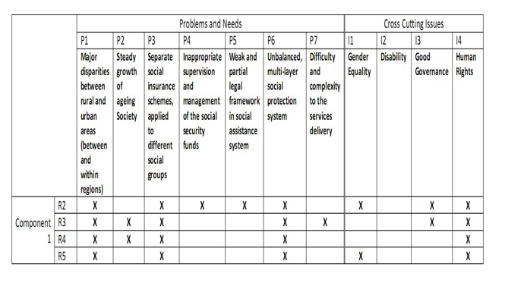

Annex 2
Topics and sub-topics - Examples of European best practices
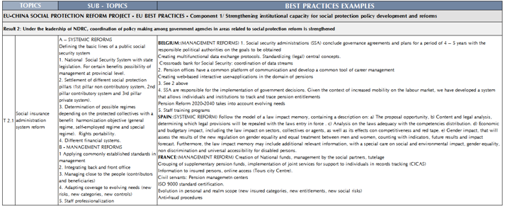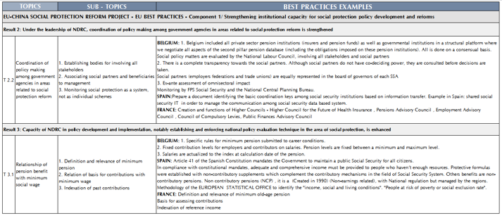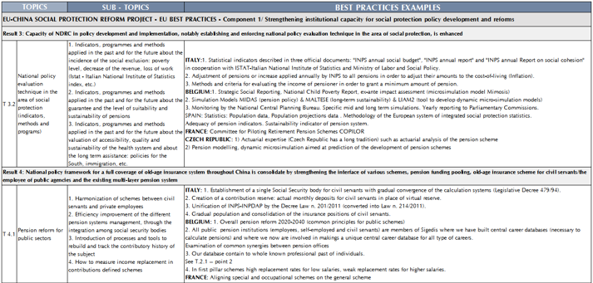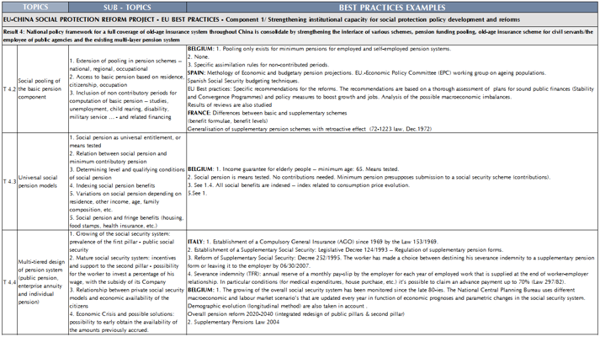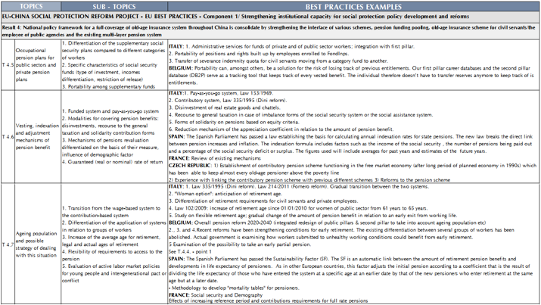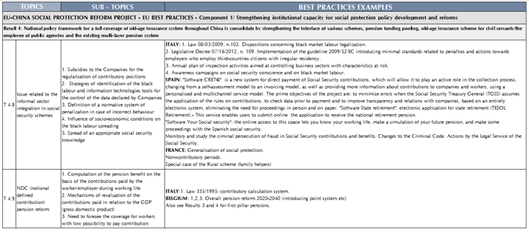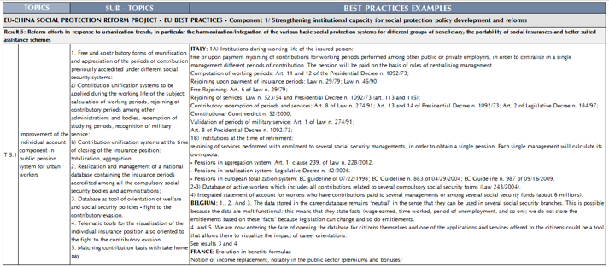

Annex 3
C1 specific Logical framework (revised)

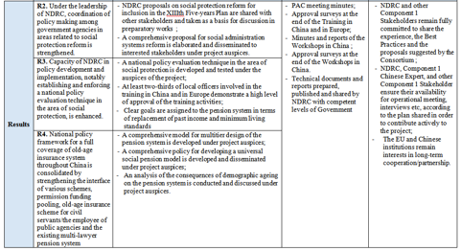

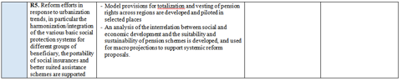

Annex 4
Programme of the Brussels Workshop

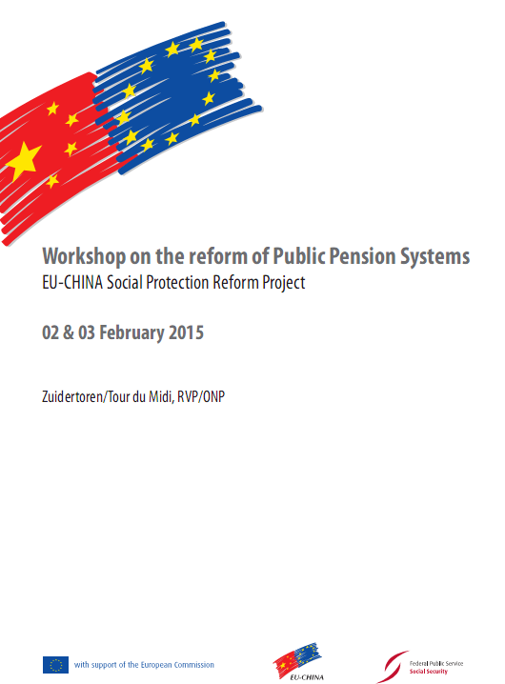

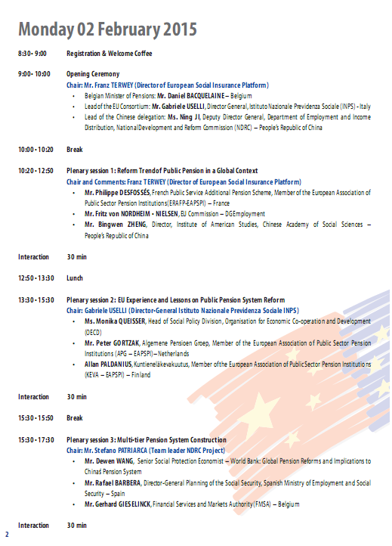

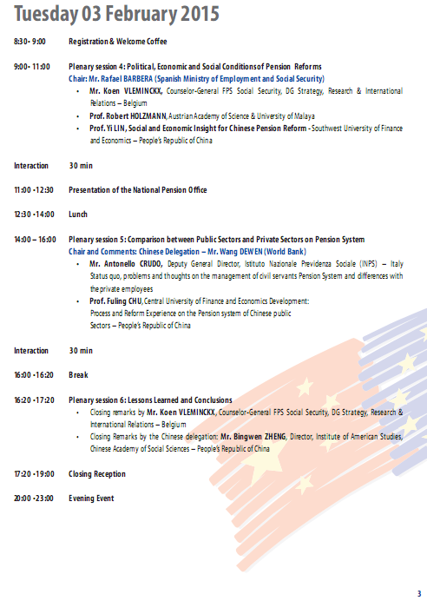

Annex 5
C1 GANTT Activity plan – March 2015 to February 2016



Annex 6
C1 Main activities and outputs - April 2015 to January 2016

RESULT | TOPIC REF. | ACTIVITIES | TYPE OF OUTPUTS | Apr 15 | May 15 | Jun 15 | Jul 15 | Aug 15 | Sep 15 | Oct 15 | Nov 15 | Dec 15 | Jan 16
2 | 1.1.1. | INPUT INTO XIIITH FIVE YEARS PLAN | REPORT (ANALYSIS & SUGGESTIONS) |  | 1ST DRAFT (15TH) |  | FINAL (31ST)
4 | 1.3.4 | MULTITIER PENSION SYSTEMS | REPORT (ANALYSIS & SUGGESTIONS) |  |  | 1ST DRAFT (EARLY JUNE) | FINAL (10TH)
4 | 1.3.2 | EVALUATION COMBINATION BASIC PENSION & INDIV.ACCOUNTS | REPORT (ANALYSIS & SUGGESTIONS) |  |  | 1ST DRAFT (15TH) |  |  | FINAL (15TH)
5 | 1.4.3 | VESTING MIGRANT WORKERS' SOC.SEC.RIGHTS | REPORT (ANALYSIS & SUGGESTIONS) |  |  |  |  |  | 1ST DRAFT (15TH) |  | FINAL (15TH)
4 | 1.3.1 | PUBLIC SECTOR PENSION REFORM | REPORT (ANALYSIS & SUGGESTIONS) |  |  |  |  |  | 1ST DRAFT (15TH) |  | FINAL (15TH)
2, 4 | 1.1.1,1.3.4,1.3.2 | PANEL DISCUSSION ONE | MEETING R. WITH RECOMMENDATIONS |  |  |  | X
4, 5 | 1.3.1,1.4.3 | PANEL DISCUSSION TWO | MEETING R. WITH RECOMMENDATIONS |  |  |  |  |  |  |  | X
2, 4, 5 | 1.1.1,1.3.1,1.3.2,1.3.4,1.4.3 | WORKSHOP TOPICS OF THE YEAR | PRELIMINARY REFORM PROPOSALS |  |  |  |  |  |  |  |  |  | X
4 | 1.3.4 | TRAINING PENSION REFORM (FRANCE) | TG REPORT, TRAINING MATERIALS |  |  | X
5 | 1.4.3 | STUDY VISIT MIGRANT WORKERS (SPAIN, POLAND, CZECH R.) | STUDY VISIT REPORT & EVALUATION |  |  |  |  |  | X
2, 4 | 1.1.1,1.3.4,1.3.2 | MISSION BEST PRACTICES PHASE ONE | REPORT BEST PRACTICES FIRST TOPICS |  |  | X
4, 5 | 1.3.1,1.4.3 | MISSION BEST PRACTICES PHASE TWO | REPORT BEST PRACTICES 2ND TOPICS, REPORT CRISIS & SOC.SEC.IN EUROPE |  |  |  |  |  |  |  | X
5 | 1.4.3 | MISSION MIGRANT WORKERS | REPORT WITH RECOMMENDATIONS (ALSO PILOT) |  |  |  |  |  |  | X
 |  | CHOOSING 2016 TOPICS | DRAFT 2016 WORK PLAN |  |  |  | X
 |  | OVERSEAS PROGRAMME 2016 HL EVENT, TG & STUDY VISIT | PROGRAMME |  |  |  | X
 |  | GUIDELINES FOR HL EVENT 2016 | PROGRAMME & MEMORANDUM |  |  |  |  |  |  |  | X
 |  | SECOND PAC MEETING | REVISED PLAN OF ACTIVITIES |  |  |  |  |  |  | X
 |  | PILOT SITES | SPECIFIC PLAN OF ACTIVITIES |  |  |  |  |  |  |  |  | X

Annex 7
Training on Multitier pension systems

EU – China Social Protection Reform Project

Training in France on Multi-tiered Design of Pension Syste
Dates : 21 June – 5 July 2015
Contact persons: Mrs. Olivia de Vendeuvre, Mr. Laurent de l’Espinay, Mr. Jean Victor Gruat
Tel.: +33 (0) 1 47 42 71 46, +8613611399375

Day# | Date | Activity | Location
1 | Sunday 21  June | Beijing to Paris, Flight CA875 02:05 – 07:25,.  Bus transfer from Paris Charles de Gaulle airport tohotel, check-in.  Hotel: Hôtel Mondial, 5 Cité Bergère, Paris 75009 | Beijing/  Paris
2 | Monday  22 June | Opening and Training Session 1  Time : 09:30 – 12:00  Organization: Ministry of Health and Social Affairs  Topic: Providing comprehensive responses to the challenges of pension systems reforms  - Welcoming adress by Thomas Fatome  - Presentation of the Chinese Delegation and introduction to the challenges of the pension reforms in China  - Introduction of the pension system and reform history in Europe  Lecturer and position:  - Thomas Fatome, Director of the Social Security Directorate, Ministry of Health and Social Affairs  - Ha Zengyou, Deputy Director General, Department of Employment and Income Distribution, National Development and Reform Commission  - Gabriele Uselli, Project Leader, Istituto Nazionale di Previdenza Sociale  Address: Ministry of Health and Social Affairs  14, avenue Duquesne 75007 Paris  Contact person and tel.: Séverine Salgado, +33 1 40 56 60 00 | Paris
2 | Monday  22 June | Training Session 2  Time : 14:00 – 17:00  Organization: Ministry of Health and Social Affairs  Topic: Providing comprehensive responses to the challenges of pension systems reforms  - General presentation of the French pension system  - Analysis of difficulties encountered and key factors of succes for reforming pension systems, in the light of the French reforms implemented over the past 20 years  Lecturer and position:  - Marco Geraci, Advisor to the General Secretariat, Pensions Advisory Council  - Dominique Libault, Director of the National School of Higher Studies in Social Security  Address: Ministry of Health and Social Affairs  14, avenue Duquesne 75007 Paris  Contact person and tel.: Séverine Salgado, +33 1 40 56 60 00 | Paris
3 | Tuesday  23 June | Training Session 3  Time : 09:30 – 12:00  Organization:Pensions Advisory Council  Topic:Strategic analysis and monitoring of pension system in France :  - Presentation of the role the Pensions Advisory Council : providing advice and regular monitoring of the pension system  - Strategic reform and overall supervision of the pension system reform in France  Lecturer and position: Yves Guegano,General Secretary, Pensions Advisory Council  Address: Conseil d’Orientation des Retraites  113, rue de Grenelle 75007 Paris  Contact person and tel.: Marco Geraci, Pensions Advisory Council +33 1 42 75 65 54 | Paris
3 | Tuesday  23 June | Training Session 4  Time : 14:00 – 17:00  Organization:Pensions Advisory Council  Topic: Strategic analysis and monitoring of pension system in France :  - Assessing the middle and long term prospects of the pension system with regards to demographic, economic and social background  Lecturer and position: Patrick Aubert, Deputy General Secretary,Pensions Advisory Council  Address: Conseil d’Orientation des Retraites  113, rue de Grenelle 75007 Paris  Contact person and tel.: Marco Geraci, Pensions Advisory Council +33 1 42 75 65 54 | Paris
4 | Wednesday 24 June | Training Session 5  Time : 09:30 – 12:00  Organization: National Old-Age Insurance Fund  Topic: The basic old-age pension scheme for French private sector employees  - A broad overview of the basic old-age scheme for French private sector employees: legal framework, coverage, etc.  - Managing and reforming the basic pension scheme for private sector employees  Address: Caisse nationale d'assurance vieillesse  110, Avenue de Flandre 75951 Paris cedex 19  Contact person, position and tel.: Anne LINDKVIST CALLESEN,  +33 (0)1 55 45 51 18 | Paris
4 | Wednesday 24 June | Training Session 6  Time : 14:00 – 17:00  Organization: Pensions Advisory Council  Topic: Inter-schemes coordination  - An explaination of different pension schemes in France  - Measures and challenges encountered of coordination and management  Lecturer and position: Jean-Luc Izard, Director, Public Interest Group “Union retraites”  Address: Caisse nationale d'assurance vieillesse  110, Avenue de Flandre 75951 Paris cedex 19  Contact person and tel.:Jean-Luc Izard ,+33 1 73 08 27 62 | Paris
5 | Thursday  25 June | Training Session 7  Time : 09:30 – 12:00  Organization: Agricultural Social Mutual Fund  Topic: Providing basic pensions to specific populations : the example of the Agricultural Social Mutual Fund  - Overview of the Agricultural Social Mutual Fund  - Challenges related to universal coverage : the example of the French agriculural sector’s pension scheme  Lecturer and position: Olivier Colin and Sonia El Heit, Manager in charge of pensions, Agricultural Social Mutual Fund  Address: Agricultural Social Mutual Fund  40 rue Jean Jaurès 93547 Bagnolet Cedex  Contact person and tel.: Olivier Colin, +33 1 41 63 77 77 | Paris
5 | Thursday  25 June | Training Session 8  Time : 14:00 – 17:00  Organization: ERAFP, AGRIC-ARRCO, MGEN  Topic: Complementary and supplementary pensions schemes  - Rationale for complementary and supplementary pensions schemes  - Financing complementary and supplementary pension schemesModes de financement  Lecturer and position: Arnauld d’Yvoire, General Secretary, Pensions Observatory  Address: AGRIC-ARRCO  16-18, rue Jules César 75592 Paris  Contact person and tel.: Arnauld D’Yvoire, +33 1 71 72 12 00 | Paris
6 | Friday  26 June | Training Session 9  Time: 09:30 – 12:00  Organization: Ministry of Finance  Topics: Management and financing of public pension schemes  - A broad overview of the public pension system in France: legal framework, policy and coverage, etc.  - Introduction and experiences of the public pension scheme in other European countries  - The management model of public pension system in France  Lecturer and position: Tim Pullman, Directorate for pensions, Caisse des dépôts et consignations  Address: Ministry of Finance  139, rue de Bercy 75572 Paris Cedex 12  Contact person, position and tel.: Tim Pullman + 33 1 58 50 96 31 | Paris
6 | Friday  26 June | Training Session 10  Time: 14:00 – 16:00  Organization: Ministry of Finance  Topics: Management and financing of public pension schemes  - Financing of public pension schemes in France  - Case introduction by Chinese delegates & introduction  Lecturer and position: Tim Pullman, Directorate for pensions, Caisse des dépôts et consignations  Address: Ministry of Finance  139, rue de Bercy 75572 Paris Cedex 12  Contact person, position and tel.: Tim Pullman + 33 1 58 50 96 31 | Paris
7 | Saturday  27 June | Rest | Paris
8 | Sunday  28 June | Hotel Check out .  Train # TGV 6689 Paris Gare de Lyon – Lyon Part Dieu (18:57 - 20:56).  Transfer between Lyon Part Dieu Station and Hotel, check-in.  Hotel: Kyriad Lyon Centre - Perrache | Paris / Lyon
9 | Monday  29 June | Training Session 11  Time: 09:30-12:00  Organization: National School of Higher Education in Social Security  Topic:Presentation of the National School of Higher Education in Social Security  - Role of the National School  - Governance of the National School  - History of cooperation between the National School and China  Address: 27 Rue des Docteurs Charcot, 42100 Saint-Étienne  Contact person, position and tel.: Laurence MAYER, Head of international relations + 33 4 77 81 15 27 | Lyon
9 | Monday  29 June | Training Session12  Time : 14:00 – 17:00  Organization: National School of Higher Education in Social Security  Topic: Pension and international labour standards  - The social security for ageing population, especially for the retirees above 65  - Pension system reform, with particular focus of developing countries  Lecturer and position: Aidi Hu, Social Security Expert, ILO  Address: National School of Higher Education in Social Security  27 Rue des Docteurs Charcot, 42100 Saint-Étienne  Contact person and tel.: Aidi Hu, ILO: +41.22.799.6111 | Lyon
10 | Tuesday  30 June | Training Session 13  Time: 09:30-12:00  Organization: National School of Higher Education in Social Security  Topic: Evaluation of pension systems and use of indicators for policy making  - The evaluation methods of pension system  - Indicators and the way to use them into the pension system  Lecturer and position: Aidi Hu, Social Security Expert, ILO  Address: the meeting room in the hotel  Contact person and tel.: Laurent de l’Espinay, ADECRI / Expertise France, +33 1 47 42 71 46 | Lyon
10 | Tuesday  30 June | Training Session 14  Time : 14:00 – 17:00  Organization: National School of Higher Education in Social Security  Topic: Towards a fourth pillar : active ageing  - The concept and meaning of the 4th pillar  - The positive economic and social influence of active ageing  Lecturer and position: Aidi Hu, Social Security Expert, ILO  Address: the meeting room in the hotel  Contact person and tel.: Laurent de l’Espinay, ADECRI / Expertise France, +33 1 47 42 71 46 | Lyon
11 | Wednesday 01 July | Training Session 15  Time : 09:30 – 12:00  Organization: Regional Fund for Pensions and Occupational Health  Topic: Implementing the pensions reform at the regional level  - Case analysis of France  - Case analysis of China by Chinese delegates  - Discussion and interaction  Lecturer and position: CARSAT expert  Address: CARSAT de Rhône Alpes 35 rue Maurice Flandin 69003 Lyon  Contact person and tel.: Carole PEURIERE, Director’s Assistant +33 4 27 82 72 60 | Lyon
11 | Wednesday 01 July | Training Session 16  Time : 14:00 – 17:00  Organization: Regional Fund for Pensions and Occupational Health  Topic: Presentation of IT management, database management for pensions  - IT used for pension system and its management approach  - Databased used for pension system and its management approach  - The meaning of using IT and database in pension system  Lecturer and position: CARSAT expert  Address: CARSAT de Rhône Alpes 31 Rue Gorge de Loup, 69009 Lyon  Contact person and tel.: Carole PEURIERE, Director’s Assistant +33 4 27 82 72 60 | Lyon
12 | Thursday  02 July | Training Session 17  Time : 09:30 – 12:00  Organization: Regional Social Security Fund for the Self-employed  Topic: Implementing the pensions reform at the regional level for the self-employed  - Case analysis of France  - Case analysis of China by Chinese delegates  - Discussion and interaction  Address: Caisse RSI Région Rhône, 55 avenue Maréchal Foch 69060 Lyon Cedex 06  Contact person and tel.: Fredrique MINY, Regional Director, +33 4 72 43 51 55 | Lyon / Paris
12 | Thursday  02 July | Training Session 18  Time : 14:00 – 17:00  Organization:European Trade Union Confederation (ETUC)  Topic: Management of pension schemes and the role of employers and trade unions  - Introduction of ETUC  - The role and responsibility of emploers in pension system  - The role and responsibility of trade unions in pension sytem  Lecturer and position: Claudia Menne, Confederal Secretary, ETUC  Address: the meeting room in the hotel  Contact person and tel.:Claudia Menne+32 2 2240428 | Lyon / Paris
12 | Thursday  02 July | Train transfer from Lyon to Paris TGV# 6628, 18:04-20:07  Hotel check-in.  Hotel: Hôtel Mondial, 5 Cité Bergère, Paris 75009 | Lyon / Paris
13 | Friday  03 July | Training session 19  Time : 09:30 – 12:00  Organization: Expertise France  Topic: The impact of economic crisis on pension sytems reform  - The impact of economic crisis on pension sytems reform  - French experiences  Lecturer and position: Monika Queisser. Head ofSocialPolicy Division, OECD  Address: Agence française d’expertise technique internationale  1 quai de Grenelle 75015 Paris  Contact personand tel.: Laurent de l’Espinay, ADECRI / Expertise France, +33 1 47 42 71 46 | Paris
13 | Friday  03 July | Training session 20 and closing  Time : 14:00 – 17:00  Organization: Expertise France  Topic: The impact of economic crisis on pension sytems reform and training conclusion  - The experiences of Spain and other European countries  - Training course conclusion and evaluation  Address: Agence française d’expertise technique internationale  1 quai de Grenelle 75015 Paris  Contact person and tel.: Laurent de l’Espinay, ADECRI / Expertise France, +33 1 47 42 71 46 | Paris
14 | Saturday  04 July | Hotel check-out .  Bus transfer from hotel to Paris Charles de Gaulle airport.  Paris to Beijing flight CA934, 20:20-12:25(+1) | Paris/  Beijing
15 | Sunday  05 July | Arrival at Beijing Capital Airport | Beijing

No. | Name | Organization | Position
1. | Mr Ha Zengyou | Department of Employment and Income Distribution, National Development and Reform Commission (NDRC) | Deputy Director General  Delegation Head
2. | Mrs Tang Ling | Department of Employment and Income Distribution, NDRC | Division Director
3. | Mr Chang Hao | International Cooperation Centre, NDRC | Division Director
4. | Ms Wang Yingsi | International Cooperation Centre, NDRC | Programme Official
5． | Mrs Liu Shuhua | Division of Employment and Income Distribution, Tianjin Municipal Development and Reform Commission | Deputy Division Director
6. | Mrs Luan Sujian | Division of Employment and Income Distribution, Shanxi Provincial Development and Reform Commission | Division Director
7. | Mrs Chen Jianhua | Division of Employment and Income Distribution, Inner Mongolia Autonomous Region Development and Reform Commission | Division Director
8. | Mrs Jiang Dan | Division of Employment and Income Distribution, Tianjin Municipal Development and Reform Commission | Deputy Division Director
9. | Mr Xia Chengui | Division of Employment, Distribution and Social Security, Shanghai Municipal Development and Reform Commission | Programme Official
10. | Mr Wang Fang | Division of Employment and Income Distribution, Jiangsu Provincial Development and Reform Commission | Division Director
11. | Mr Liu Shuqing | Department of Social Affairs, Fujian Provincial Development and Reform Commission | Division Director
12. | Mr Huang Xiaojun | Division of Employment and Income Distribution, Jiangxi Provincial Development and Reform Commission | Deputy Division Director
13. | Mrs Chen Jing | Division of Employment and Income Distribution, Henan Provincial Development and Reform Commission | Deputy Division Director
14. | Mr Zhan Gang | Division of Employment and Income Distribution, Hubei Provincial Development and Reform Commission | Deputy Division Director
15. | Ms Lu Peipei | Division of Employment and Income Distribution, Hunan Provincial Development and Reform Commission | Programme Official
16. | Mr Xu Wei | Division of Employment and Service, Guangxi Zhuang Autonomous Region Development and Reform Commission | Deputy Division Director
17. | Mr Pu Xiaojun | Division of Employment and Income Distribution, Sichuan Provincial Development and Reform Commission | Deputy Division Director
18. | Mr Yang Shu | Division of Employment and Income Distribution, Gansu Provincial Development and Reform Commission | Division Director
19. | Ms Wang Xinyi | Division of Employment and Income Distribution, Shaan’xi Provincial Development and Reform Commission | Programme Official
20. | Mr Liu Wenxin | Division of Employment and Income Distribution, Ningxia Hui Autonomous Region Development and Reform Commission | Division Director
21. | Mrs Lu Cuiping | Division of Employment and Income Distribution, Xinjiang Uygur Autonomous Region Development and Reform Commission | Deputy Division Director

Incorporating the changes agreed upon between NDRC and Component 1, subsequently endorsed by the PAC on its 21 April meeting.
ACFTU indeed took part in the first meeting of the PAC.
The participation of some of Chinese experts in the Brussels Workshop – see below, 2.2 – was financed through the earmarked resources for C1 Chinese experts. However, the details of this financing were not available at the time of writing this report.
For details on related study visit, see below, point 3.2.2
ACFTU and the ILO jointly organized in April 2015 in Kunming a seminar on migrant workers’ social security rights, to which the C1 EU Resident expert was invited to present two lectures. Relevant documentation can be retrieved from http://www.jvgruat.com/SPRP/TechnicaDocs/Docs topic143Migrants/migrantsiloacftu/
Topic 1.3.7, originally proposed for the year 2017. As for the venue, Spain has expressed its interest – however there are some uncertainties linked to forthcoming general elections. Since in-country clearance has to include the venue, it might be useful to already consider a possible alternative.

