DELEGATION FROM GUANGDONG PROVINCE VISITS SPAIN, FRANCE
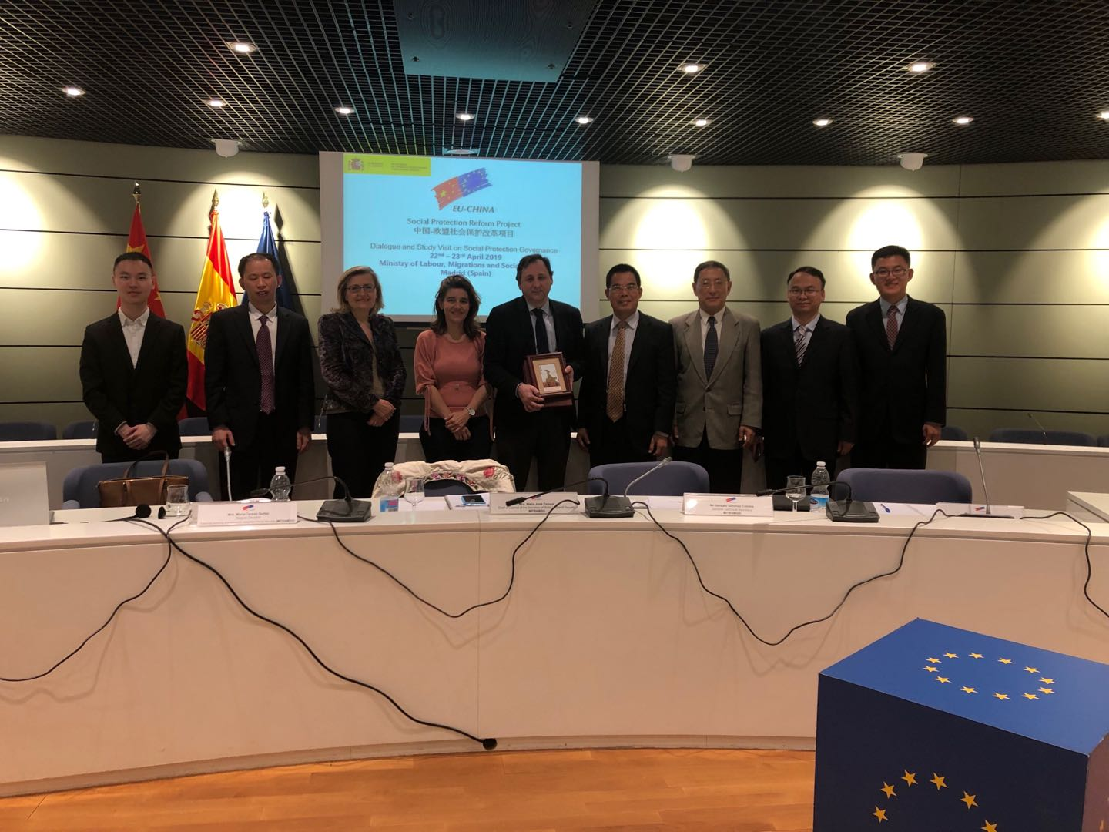
The delegation visiting the Spanish Ministry
According to the work plan of EU-China Social Security Reform Project (SPRP) Component One, Mr. Huang Huadong, Chief Economist of Guangdong Provincial Development and Reform Commission led a delegation to visit Spain and France from April 21 to 28, 2019 on the theme of social security management and administration. The delegation was sent by the National Development and Reform Commission and under the invitation of the Spanish Ministry of Labour, Migration and Social Security (MLMSS) as well as Expertise France. In Spain, the delegation met and exchanged views with the officials of MLMSS and visited Social Security IT Management Center (GISS). In France, the delegation had in-depth discussion with French National School for Higher Social Security Studies (EN3S), National
Fund for Family Benefits (CNAF), Advisory Committee on Pensions (COR), National
Institute for Statistics and Economic Studies (INSEE) and General Complementary Scheme for National Education (MGEN). During the study visit, the delegation gained a general understanding of the history and status quo of the social security system of France and Spain, and their experiences and practices provide reference for the development of social security of Guangdong Province. Mr Zhang Guoqing, SPRP Component One Main Expert (Operations) accompanied the delegation. This activity is part to the overall project programme of activities with Pilot sites, and aims at facilitating sustainability in cooperation once the project has been completed. Full documentation can be retrieved from the project Memorabilia

